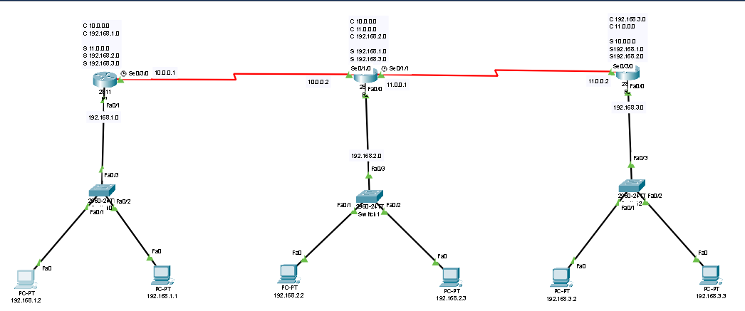

**Router Configuration R1**

Router>

Router>enable

Router#configure terminal

Router(config)#hostname R1

R1(config)#interface fastEthernet 0/0

R1(config-if)#ip address 192.168.1.1 255.255.255.0

R1(config-if)#no shutdown

R1(config-if)#exit

R1(config)#interface serial 0/3/0

R1(config-if)# ip address 10.0.0.1 255.0.0.0

R1(config-if)#no shutdown

R1(config-if)#exit

C 10.0.0.0

C 192.168.1.0

S 11.0.0.0

S 192.168.2.0

S 192.168.3.0

R1(config)#ip route 11.0.0.0 255.0.0.0 10.0.0.2

R1(config)#ip route 192.168.2.0 255.255.255.0 10.0.0.2

R1(config)#ip route 192.168.3.0 255.255.255.0 10.0.0.2

R1(config)#exit

R1# wr

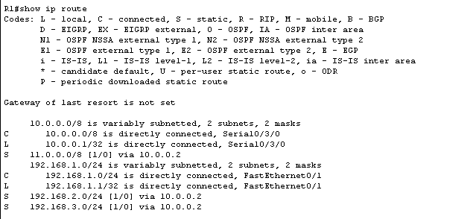

**Router Configuration R2**

Router>

Router>enable

Router#configure terminal

Router(config)#hostname R2

R2(config)#interface fastEthernet 0/0

R2(config-if)#ip address 192.168.2.1 255.255.255.0

R2(config-if)#no shutdown

R2(config-if)#exit

R2(config)#interface serial 0/1/0

R2(config-if)#ip address 10.0.0.2 255.0.0.0

R2(config-if)#no shutdown

R2(config-if)#exit

R2(config)#interface serial 0/1/1

R2(config-if)#ip address 11.0.0.1 255.0.0.0

R2(config-if)#no shutdown

R2(config-if)#exit

C 10.0.0.0

C 11.0.0.0

C 192.168.2.0

S 192.168.1.0

S 192.168.3.0

R2(config)#ip route 192.168.1.0 255.255.255.0 10.0.0.1

R2(config)#ip route 192.168.3.0 255.255.255.0 10.0.0.2

R2(config)#exit

R2# wr

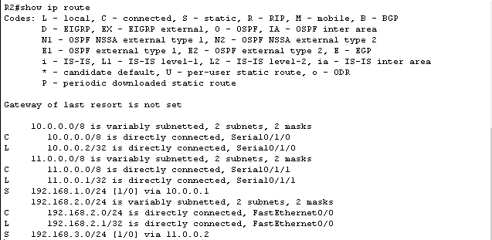

**Router Configuration R3**

Router>

Router>enable

Router#configure terminal

Router(config)#hostname R3

R3(config)#interface fastEthernet 0/0

R3(config-if)#ip address 192.168.3.1 255.255.255.0

R3(config-if)#no shutdown

R3(config-if)#exit

R3(config)#interface serial 0/3/0

R3(config-if)#ip address 11.0.0.2 255.0.0.0

R3(config-if)#no shutdown

R3(config-if)#exit

C 192.168.3.0

C 11.0.0.0

S 10.0.0.0

S192.168.1.0

S192.168.2.0

R3(config)#ip route 10.0.0.0 255.0.0.0 11.0.0.1

R3(config)#ip route 192.168.1.0 255.255.255.0 11.0.0.1

R3(config)#ip route 192.168.2.0 255.255.255.0 11.0.0.1

R3(config)#exit

R3# wr

